The design of Prisoner Escape from the Tower : an interactive location aware historical game.

Josephine Reid, Ben Clayton, Tom Melamed, Richard Hull, Phil Stenton
Hewlett Packard Laboratories
Bristol, UK
josephine.reid@hp.com

Aileen Peirce, Chris Gidlow, Susan Holmes
Historic Royal Palaces
London, UK
aileen.peirce@hrp.org.uk

ABSTRACT
In this design case study we describe the process by which we designed, tested, developed and ran a field trial of an interactive location aware historical game called “Prisoner Escape from the Tower”. The game uses mobile devices with GPS and Active RF transmitters and receivers to trigger events and interactions around the tower and with the Beefeaters. The game is based on authentic historical events and players help prisoners to escape by completing tasks which allow them to re-enact their actual escapes. The paper describes how the game was developed between two geographically dispersed teams and the steps involved in creating a location specific interactive game.
The paper contributes to designing interactive systems by extending the body of knowledge for location based media experiences and highlighting the key enablers for a successful design. It also shows how character triggered interaction, enabled by Active RF can be used to involve other people in game play to great effect.
Categories and Subject Descriptors
H.5.2 User Interfaces
General Terms
Design, Human Factors.
Keywords
Mediascape, mscape, mobile, game, locative media, situated media, experience design.

INTRODUCTION
The mobile, location aware design space is a relatively new field with different design characteristics to web or PC applications. The vision is to use pervasive and mobile technologies to create rich compelling context sensitive experiences that can be experienced in the world rather than at a desk. Media can be delivered to you in place, as you move through the landscape and that media can be tailored to you depending on where you are, where you have been, what you can see and what else can be sensed in the environment. In this space knowledge of the environment is as important a part of the design process as knowledge of the user.
The distinctive characteristic of location based experiences is the relationship with the physical world. The way in which location is embedded and presented to the user depends on the capabilities of the device the user carries or wears and how the designer creates the interface. Three distinct styles have so far emerged for incorporating location into the end user experience
- Self reported position
- time based
- automatic sensing of the users position
Self Reported Position. When a user reports their location on their media player the particular piece of media designed for that particular location is played. The user can report their location by entering a code on their media player, entering an sms code on a phone [1], scanning a bar code [9, 11], entering their position on a map [2], pointing a device at an infra-red beacon or sensing an RFID tag [4, 6]. In all cases there is an explicit action that the user needs to perform to request the media. This explicit interaction forces the user to make a conscious action to provoke the next piece of narrative. The degree to which this interaction breaks the immersion in the narrative flow of the overall experience depends on how intuitive or natural the interaction is.
Time based. In a timed location based experience the user listens to a continuous audio track which leads them through a particular space and directs them where to go, when to stop and when to move on. For example artists such as Janet Cardiff http://en.wikipedia.org/wiki/Janet_Cardiff and Duncan Speakman http://duncanspeakman.net have created walking pieces which weave fictional narrative with descriptions of the actual landscape. The pacing and flow of the experience is carefully designed to fit with the time it would take for an average user to walk through the area. The pace and flow of the narrative can be designed in a linear fashion. The only controls the user might have to interact with the media is to pause the soundtrack if they want to stop for longer than the designer intended. The user does not have a choice as to which direction they walk or what they listen to next.
Automatic sensing of the users position. In a triggered experience the user carries a mobile device with an attached sensor which can detect when the user is in a particular physical space and automatically play a piece of media that the designer has placed there. The location system could use wireless network beacons, ultrasonics, radio, bluetooth or GPS but all of these except for GPS require beacons or transmitters to be placed in the physical environment. In this paper we will describe a GPS and Active RF triggered experience.

PRISONER ESCAPE FROM THE TOWER

Background
The experience which we call a mediascape was created using mscape www.mscapers.com. The mscape technology platform consists of
- an authoring tool called the maker, which has a drag and drop map interface for associating media items with physical places in the world and defining the logic for how the resulting mediascape plays out to the user.
- A library manager, for organizing mediascapes on your pc and synchronizing them with your mobile device.
- a client application which plays mediascapes that are triggered by GPS as you walk outside. The client will run on any windows mobile device.
- a website where consumers and professionals can create, post and share their mediascape experiences to be enjoyed.
The mscape platform has evolved based on the experience and learning from several user research trials and feedback from users. [8].
The design team consisted of researchers who were skilled in the use of the mscape tools (HP) and staff from the Historic Royal Palaces Interpretation team (HRP) who were knowledge experts in the stories and history of the Tower of London.

Rationale
The motivation for working on the project from the HP side was to validate a design process, trial Active RF sensors and to demonstrate this new medium in a prestigious place which is steeped in history, authenticity and ambiance. The motivation for the HRP team was to understand the possibility of future technology, to learn how to design such an experience and to trial it with invited members of the public.
Conference’04, Month 1–2, 2004, City, State, Country.
Copyright 2004 ACM 1-58113-000-0/00/0004…$5.00.

Permission to make digital or hard copies of all or part of this work for personal or classroom use is granted without fee provided that copies are not made or distributed for profit or commercial advantage and that copies bear this notice and the full citation on the first page. To copy otherwise, or republish, to post on servers or to redistribute to lists, requires prior specific permission and/or a fee.

Audio tours are already available for rent at the Tower of London and many of the other royal palaces. Whilst they are popular and useful the HRP team felt that they tended to be somewhat formulaic in their delivery and also isolating in group situations. Their aspiration was to design something that was more social, appealed to children and teenagers and was flexible. The appeal of the mscape platform was in its flexibility; the ability to easily create and publish content was seen as a great advantage over their existing audio tour production system. The idea that in the future people might be able to use their own personal devices and download a range of mediascapes was also appealing.

Design workshops
We started the design process with a two day workshop at the Tower with members of both teams present. The two major goals for the workshop were to familiarise the HRP team with the nature of mediascapes and the mscape development platform and to decide upon a suitable subject for a trial mediascape.
To achieve the first goal the HP team laid out a mediascape game called “Doubloons” in the grounds of the tower and got the HRP team to play it. Doubloons is a trading game whereby you visit islands, talk to the islanders and buy and sell items. While you are at sea pirates can board your ship and rob you of your items. As a result of playing the game the HRP team became aware of
- how the simple mechanic of visiting a place and triggering media could be effective and compelling
- how the game format encouraged competitiveness
- the erratic nature of GPS
We knew that this learning was important, without actual experience it is hard to create a shared understanding of the possibilities and limitations of the medium [7].
After playing the game and discussing alternative ideas we quickly decided that a game was an effective way to engage children, teenagers and families and that the prisoners who have escaped from the tower would be a rich subject area for a game.

Rapid Prototyping
We then moved into rapid prototyping mode so that the HRP team could be aware of the entire development process and so that we could all get an idea of what works well in the environment and what does not. Our approach to design is to rapidly iterate through a number of different design options as we know from experience that design ideas which look fantastic on paper can be very different in practice. If you spend too long designing an idea before trying it out there is a temptation to over complicate the idea or add in more subtlety than the medium really affords. This is because the act of walking around a space and paying attention to things in the environment takes far more time and effort than moving a mouse on the computer screen or listening to sounds in an indoor environment. When you design and prototype primarily on the computer you tend to fall into the mindset of creating a computer application and location based applications are very different. Rapid testing of ideas is essential to keep the design real, achievable and compelling.
We wanted to test the ability to move between outdoor GPS triggered events and indoor IR beacons. The HP team led the HRP team through a process of identifying a couple of prisoner stories that we could rapidly develop. We identified stories that would involve real locations around the tower. For example the first story that we prototyped was of John Gerrard who was held in the Salt Tower and escaped by climbing along a rope from the Cradle Tower to a boat waiting alongside the wharf which then carried him to safety. The HRP team wrote the dialog to retell the story in a way that leads people from one place to another meeting and interacting with characters that they encounter in particular locations. Once the script was written we recorded the dialog so that the sound files could be imported into the mscape authoring tool and be attached to regions placed on a scale map of the Tower. The HP team then rapidly created a mediascape using the content created by the HRP team for everyone to try.
The HRP team were keen to see how a mediascape might play out within the Medieval Palace which is a series of rooms that a visitor walks through. They developed the narrative and test audio files for the story of Alice Tankerville, who seduced her guard and persuaded him to help her escape. The narrative related to the different rooms and we used Infra Red (IR) beacons to trigger it.
As a result of the first prototypes we were able to change the design and hone in on the interaction styles and narrative styles that we wanted to develop. The test showed that the conflict with other exhibits, sound and crowds in the Medieval Palace meant that the experience was not very satisfactory. We felt it was more rewarding to use the mediascape to lead people to less congested areas of the tower and encourage people to explore. We also wanted to engage the Yeomen Warders (Beefeaters) in the experience and maybe even have them carry transmitters which could react with the mediascape when they were nearby. The IR beacons worked well enough as triggers when you enter a room but because IR is line of sight you have to point your device at the beacon for it to work and so is not an ideal mechanism for Beefeaters to carry. Radio beacons would be more discrete and could be carried in pockets and so we decided that we would conduct further tests using Active RF transmitters.

Parallel development
The prototyping exercise gave us enough practical experience to define a process and design a game structure with which we could continue to design and development independently with HRP creating the content and HP implementing the design. As the HP team were based a hundred miles away from the Tower it was important to define a parallel development process with well defined responsibilities. HRP would be responsible for the content creation and testing and HP would be responsible for the overall design and implementation of the game.
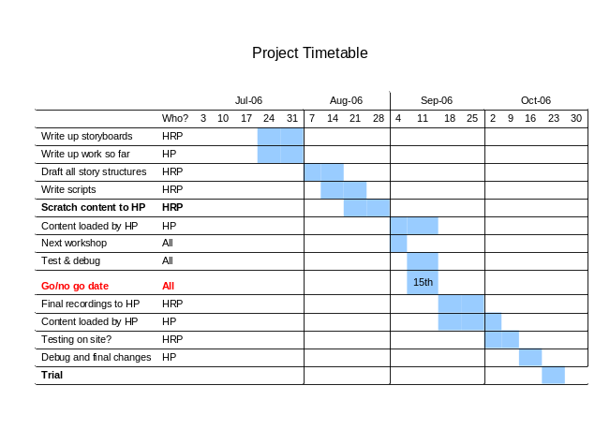
Figure 1. Project Timetable
Our game structure was a series of missions in which you agree to help a Prisoner Escape by visiting different places to enlist help, find objects or even virtually bribe Beefeaters. We picked six escapee stories based on how interesting they were, how well they related to locations around the tower and their diversity. For example we wanted to have men and women and animals as escapees (the Tower of London was at one time a zoo). We also wanted to include cameos of famous prisoners like Anne Boleyn and Guy Fawkes who you would encounter around the grounds in between missions.
We also wanted to incorporate some form of “score” or reward to encourage competitive game play. This was eventually designed as having two elements: notoriety and years sentenced in the tower. When you rescued a prisoner you became notorious and a bounty is put on your head, each successive prisoner you rescue increases the bounty depending on how easy or hard the mission was. You could also get sentenced to years in the tower if you were caught by Beefeaters or made mistakes in your mission. Thus the most successful players would be those with the largest amount on their head and the least number of years sentenced.
We defined a project plan shown in Figure 1 with a follow on workshop to test the game with temporary content and then further tests scheduled until the planned trial date. We also agreed a Go/No Go date on which we would assess how far we had got with the development and how confident we would be that we could hit our planned trial date. Our trial was planned for the school holidays so that we would be able to recruit children and families.

Meta Design document.
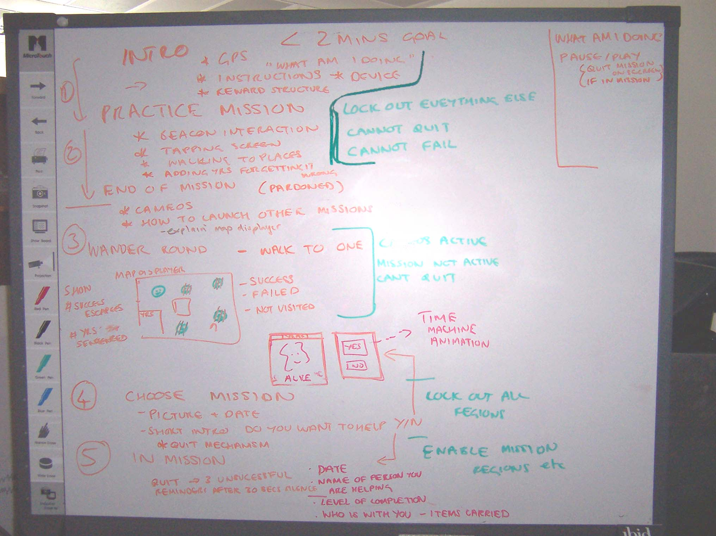
Figure 2. Meta design of the game
The overall game mechanics and flow was designed by HP. The output from our design meeting is shown in Figure 2. This design was then written up in a document which defined how the overall game should work, how each of the missions were entered and exited and what should be defined for each mission script. The script schema would define how HRP would write the scripts so that they became an implementation specification. This document was passed to HRP for approval and for them to work on the detailed script design for each of the missions.

Scripts
HRP designed and wrote a script for each individual mission. The design process consisted of fleshing out the story lines, locating the areas of the Tower that correspond to where the actual escapees were held or where they escaped from and deciding what extra game interaction there might be. For example in most missions players are asked to answer questions that are related to the escape such as this extract “Are you visiting a prisoner? You know there’s ways of making sure they regain their freedom. Men like me can be a big help. What is it you need? Do you want to - smuggle in a rope - Get the guards drunk - Pay a ransom – or arrange a visit from Nithsdale’s wife.” Selecting the wrong answer would result in you getting five years in prison and then you can try again.
At the beginning of the script is a definition of the era of the mission, the characters involved so that we knew how many different people to cast for the final audio recordings and then the actual narrative itself. The narrative was written with numbered entries for each section of dialogue. Each numbered section would correspond to an audio file that would be named with the escapee initials and the section number. For example PB3 will be the third section of the polar bear script. The script section would name the character who is talking, the words they will say, what triggers the dialogue (does it automatically start when the previous piece ends or is it triggered from a beacon, GPS or a user action such as tapping on the screen), what images are shown and any conditions for the next event.

Example section from the Polar Bear script
1260s? (Henry III)
Characters
Polar bear : a gift from the King of Norway to Henry III
Bear’s keeper
Sheriffs of London
Keeper of the Wardrobe: in Wardrobe Tower
Interaction
- Polar bear: God Dag! Hello! Can you help me get out of here?
  - Triggered by GPS
  - Media : audio, image of polar bear
- Narrator: Do you want to play the polar bear adventure? Press YES or NO on your screen.
  - Automatic trigger (starts when the previous piece ends)
  - Media : YES/NO screen
  - If YES go to (3). If NO return to default screen.
- Polar bear: Don’t look so surprised – yes you’re standing in the Bear House. Didn’t you know there was a zoo here? I’ve been imprisoned here for over a year now and boy, am I am feeling fed up. I mean, they do their best for me, (I’m sure I’m costing them a fortune in food) but I’m still starving and I’m really bored. You know what I’d really love to do? Go swimming to catch my own supper. I’ve heard the river Thames is full of lovely salmon…do you think you could help me get out of here?
  - Automatic trigger
  - Media : audio, image of polar bear

Region design
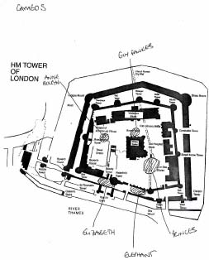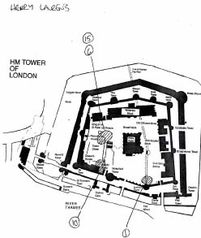
Figure 3. Region layout design for the cameos and for the Henry Laurens mission
Location based experiences can be designed by thinking of the places in the real world that will trigger media when a user walks to them. These places can be marked on a map as regions.
As part of the content design HRP needed to design the region layout to specify where each mission should start and end and where people would need to go to complete tasks and interact with other virtual characters as part of each mission. They also defined the areas around the tower where you would encounter the cameo sequences. The areas were as close as possible to known areas of the tower where the real characters would have walked or were held prisoner. For example you met Anne Boleyn near the execution block where she was beheaded.
The region design dictates how people move around the tower and which missions they are most likely to encounter. The region design was drawn on an outline map of the tower and faxed through to the HP team to implement in the mscape authoring tool.
Figure 3 shows the region layout design for the Cameos and the Henry Laurens mission.

Mediascape implementation
The HP team used the scripts, the region layout design and the scratch content files to create the mediascape using mscape. The content files were a mixture of images and audio files. The mscape maker allows regions to be drawn on a scaled map and to attach behaviours to events such as entering a region, pressing a button on a screen or a timer going off. For example when entering a region a particular piece of media might play and an image might show on the screen. The maker also allows groups of regions to be enabled or disabled so that it was easy to develop and visualise the individual missions without the map becoming too cluttered.
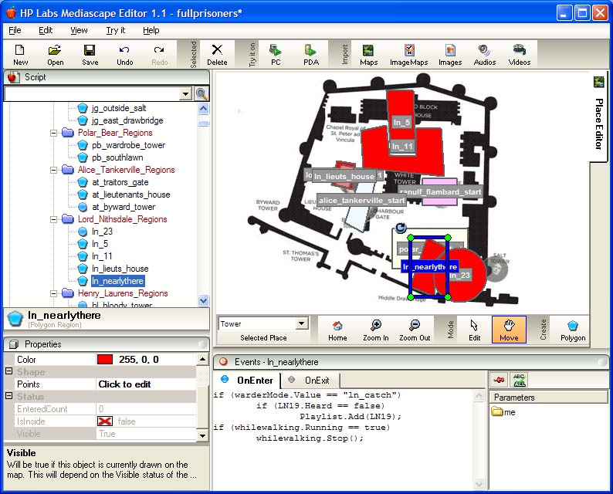
Figure 4. mscape maker screen shot
Figure 4 shows a screen shot from the mscape maker with the regions for the Lord Nithsdale escape mission shown as well as the start regions for each of the missions. The regions for all of the other missions and the cameos are hidden. The region ln_nearlythere is highlighted and the behaviour that is associated with entering that region is shown in the event script window.
The scripts written by HRP acted as a specification of the mediascape behaviour which was then implemented in the mscape maker. A shared file store space was set up to share the scripts, content files and the completed mediascapes.

Test and iteration
The mediascape was uploaded by HP to the shared file area so that HRP could download and test it in the Tower itself. After each test the HRP team would email feedback to HP, refine the scripts and re-record the content. The most common change made to the scripts were to cut them down in length and to make them more concise. The amount of dialog that people are happy to listen to when they are standing in a public space is quite short, ideally around thirty seconds. It is difficult to write concise, entertaining narrative in short episodic bursts that can still tell a story and engage people with the characters.
There were several iterations of the mediascape. Some iterations were to fix bugs or problems discovered in the testing and some were script revisions and new content. Bugs were reported by email and new content and revisions were put in the shared file area.
A second workshop was arranged a month after the first one. At this workshop we tested the use of Active RF transmitters.

Using Active RF transmitters
The Active RF transmitters and receivers that were used were custom built to our specification by Pyxis Design. The transmitters were small and battery powered, so as to be easy to place, each one sent a unique signal once per second on a frequency of 433MHz. The unique codes could then be detected by the receivers attached to each iPAQ. If the receiver could ‘hear’ a code then the system knew it was within range of that beacon. The exact ranges were set by changing the size and shape of the aerials on the beacons, this was an iterative process that was best done by testing in-situ as the exact radio properties of each room and building was very hard to predict.
A user is also a relatively good shield of RF signals and so it was not possible to predict exactly how each person would ‘hear’ the beacons as the way they held the receiver, their orientation to the beacon and other people in the vicinity could greatly affect the range. However with good interaction design and good beacon placement it was possible to greatly mitigate the effect these differences had on the user experience.
To establish the best arrangement of beacon and aerial successive tests were carried out. In general we wanted the receiver to ‘hear’ the beacon as soon as a person entered the room but not before. We found that the thick stone walls of the tower were very advantageous, just as they blocked all GPS signals they also blocked all Active RF signals from leaking between rooms, so a beacon placed just inside a doorway tended to flood the room with signal but not propagate beyond the room. The aerials were then fine tuned in length to reduce the range until it only just filled the room but did not spread beyond.
Likewise we adjusted the aerials on the transmitters carried by the Beefeaters so that a user would need to be approximately 5 meters away before the receiver that the user was carrying could hear the transmitter that the Beefeaters were carrying.

Recording production content
Once the overall flow of the missions and the tests were satisfactory HRP found people to record the proper audio for the mediascape. For this trial we did not hire professional actors, the HRP team engaged Beefeaters heritage staff and friends to play the parts. The audio files were uploaded to the shared work area and the HP team edited them so that the audio levels were satisfactory. In previous trials such as Riot! 1831 [3] a sound editor was employed to produce very fine production quality audio. Audio is such an important aspect of the mobile experience and high quality sound and careful use of sound effects and ambience really enhances the experience. However as this was a free experimental trial and we did not have very long to produce the finished mediascape we did not invest too much time or resource on the audio production quality.
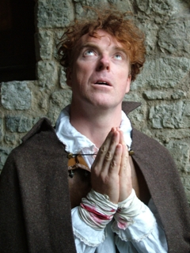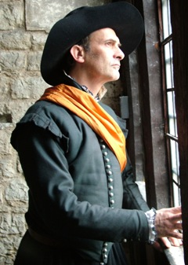
Figure 5. Character photographs used in the game.
Likewise the images used in the interface were created with a limited amount of graphic design input. The images of the escapees and other characters were created using photographs of the HRP team and their friends dressing up in their stock of period costumes.
The mscape authoring tools make it easy to replace test audio and image files with final production ones. The content files can simply be replaced and as long as they have the same name then nothing else in the mediascape needs to change. This is an important aspect of the design process. Final content production and editing is one of the most time consuming parts of the process. It can also be expensive and inconvenient to bring back actors to re-record pieces if they need to be changed. It is important that this final production phase be left as late as possible in the process and the main mediascape testing be done with test and scratch audio simply recorded with temporary recordings and images. Although the scratch audio is created relatively quickly it is important that the delivery and clarity of the narrative be good enough to have a valid test of timing and effect of the storylines.

Preparation for the trial.
In the final couple of weeks before the trial we prepared the logistics and materials for the trial. Invitation to participate in the trial was sent to families and friends of Historic Royal palaces and to families and friends of HP employees. We allowed a maximum of two hours for each participant to try out the game. We also sent a registration form for each participant to fill in before they came along. Our questions on the form asked for gender and age (within a range), familiarity with the Tower, previous experience of doing audio tours and previous use of handheld computers. As we are interested in how expectation affects an experience we also asked questions about some of their expectations such as whether they expect to walk around, learn about the history of the tower and involve other people. We also asked whether they expected the equipment to work perfectly.
We had twenty iPAQ devices available which had to be re-charged at times throughout the day. We also had fifteen Active RF pingers which would be distributed to the Beefeaters who were on duty that day to carry around in their pockets. Two Active RF pingers were to be placed in the Salt Tower and the Cradle Tower so that they could trigger media inside the towers.
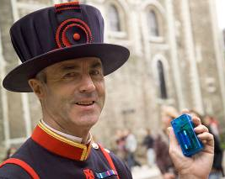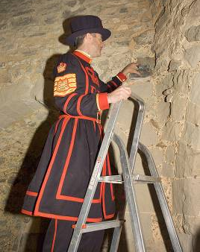
Figure 6. RF Pinger carried by a Beefeater and another being placed inside a tower.
The iPAQs had to be connected to RF receivers and then all put into a waterproof bag which could be hung around the participants neck along with a pair of headphones and an instruction card. On the instruction card was a map of the tower highlighting the trigger points for the start of an escapee mission and areas that they would need to go to within a mission.
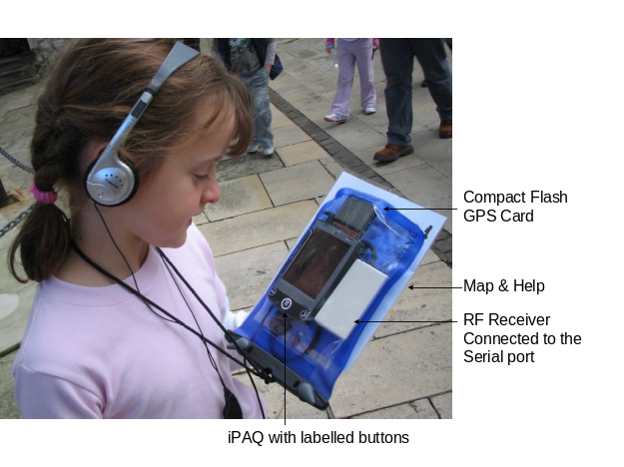
Figure 7. Equipment given to each participant.
To help the process we devised a make shift charging stand which helped reduce the mess of cables from the amount of chargers we needed for all our devices. The charging stand allowed us to monitor battery levels, start up the application so that the devices were ready to go out when large groups came in and to store and charge devices overnight.
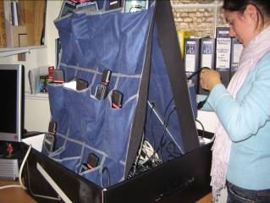
Figure 8. The iPAQ charging station
The HP team joined the HRP team a day before the trial start to do final testing and refinement and to set all the equipment up. We also produced a handout map and instructions that could be attached to each of the devices.

THE TRIAL
We had 178 participants try out the game during the week long trial. Ages of participants ranged from under 10 to over 60 with half of the participants being under 16 and 65% being female.
We had several family and extended groups participate and it was interesting to observe how they got on. If the group had several teenage children it was most successful if the adults allowed the children to go on ahead and play the game at their own pace. The children would enjoy solving the puzzles and reporting back to the adults what they had done and what to do next. If the group had a lot of very young children (under ten) then they worked well if there was a high ratio of adults. Quite often the adults would share their sets with very young children allowing them to hear the stories and see the images on the screen. If there was a problem with the equipment then the adult tended to swap their set with one of the childrens so that the children could play the game. In general if the children were happy then the adults were happy.
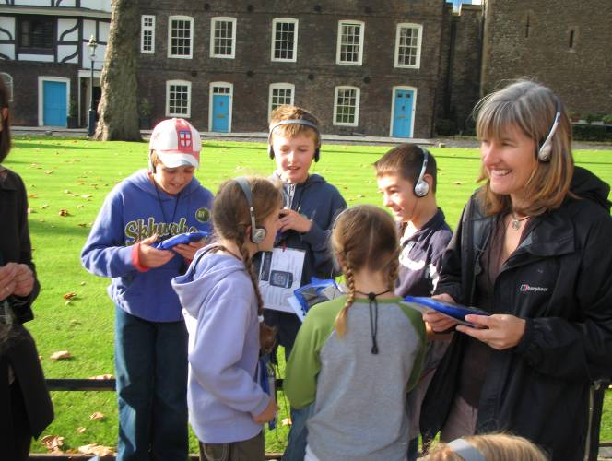
Figure 9. A Group of players doing the game
However this is not to say that adults did not enjoy the game as well. Those who played the game without being responsible for children reported equally high enjoyment ratings.
The most problematic situation was when the equipment was faulty in a large group of young teenage children with few adults. In one instance one boy got very upset as his device would not work and all of his friends devices were ok. The adult responsible for the group would not let the other children go on ahead and so the whole group had to wait while the equipment was sorted out. Even when they got going the same boy had lots of problems with his device and became increasingly frustrated and upset especially as his friends were getting along quite well.
Game play encourages competition and if not all players start with a level playing field it can cause disenchantment and anger. GPS accuracy can vary between devices even if they are the same make and model. GPS accuracy can also change depending on the weather conditions, the time of day and the number of people around you. It is a challenge for future multi-player game design as it points to the need to create games that can accommodate a varying level of capability in the end user devices. If possible the game should be devised so that it is still possible to compete effectively without necessarily the fastest or most powerful device.
The most common cause of problem was the devices not getting a GPS signal. This could be due to it being a bad time of day with not enough satellites visible overhead, or it could be because one of the iPAQ connections had disconnected or because the battery had run too low.

In and out of towers.
The game was designed so that outside it used GPS to trigger located events and inside the next part of the story was triggered using Active RF transmitters placed within the towers. We know that screens can be very hard to see in bright sunlight and so the indoor sequences gave us more opportunity to show images and video. For example in the John Gerrard escape story he writes a secret note on parchment using Orange Juice. Holding a candle beneath the parchment to slightly singe the paper reveals the hidden writing. The HRP team created a quick video of this process which could be seen when inside the tower to show what happens.
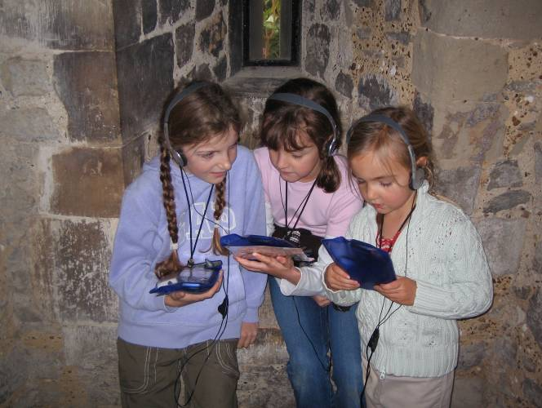
Figure 10. Girls inside the Salt Tower watching the secret writing reveal.

Interaction with the Beefeaters
One of the key points of interest was how the game was enhanced by the threat of being caught by the Beefeaters. Players were made aware that Beefeaters would be carrying devices that could detect your device if you were close by and that if you were with a prisoner then they would catch you and sentence you to extra years in prison. This added considerable frisson to the game play. We observed adults screaming and running away from Beefeaters when they spotted them and in some cases the Beefeaters joining in with the game and pretending to give chase. In the normal course of events Beefeaters walk around the Tower ground patrolling, helping visitors, giving talks or just moving between places. As the Beefeater uniform is so distinctive it has great visual impact when you see them and you never know where they will be. Even though not all of the Beefeaters were carrying transmitters their visual presence was enough to add excitement and cause the participant to hide behind a wall or runaway.
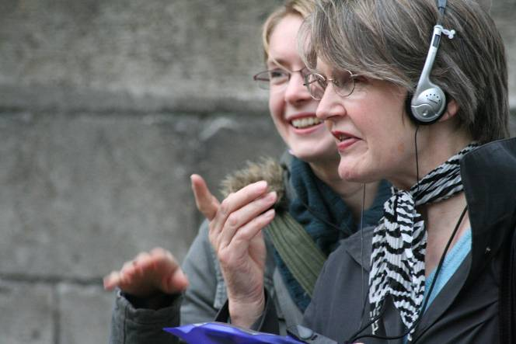
Figure 11. Adults keeping an eye on a Beefeater.
Research is ongoing as to the kinds of behaviours that emerge when people play mobile location-aware games [12]. Awareness of things in the environment and other players is an essential element of location based games. Studies of a commercial location based phone game called “Mogi” [10] have shown that players will modify their mobility patterns if they become aware of nearby game elements that they can interact with. Discussion of where other players are and where they might go is another common element in the game play. In the Tower game we also observed players alerting one another to the location of Beefeaters and discussing their strategies to avoid them or hide from them. The fact that the Beefeaters were not “programmed” or even actively engaged in the game made their encounter spontaneous and non-predictable. The physical layout of the tower with its many walls, courtyards and buildings made encounters even more unpredictable as you might not see someone until you turned the corner. This chance element added greatly to the excitement of the game play.
So that the Beefeaters were not always cast as foes we used the Ranulf Flambard escape story to allow more friendly interaction. Ranulf Flambard the Bishop of Durham escaped from the Tower of London by inviting his guards to a party, getting them drunk and then climbing out of the tower window down a rope which had been smuggled to him in a gallon of wine. In this mission participants had to invite at least two Beefeaters to Ranulfs party which would happen automatically if the Beefeater was carrying a transmitter and the user got close enough to them. Whilst this was a nice idea it was the most problematic when not all Beefeaters were carrying the transmitters. In contrast when the Beefeaters could catch you the mere sight of them was enough to make you flee which meant that even if they were not carrying a transmitter they still had an effect in the game play.
If we were to redesign the game we would make the invitations a social mechanic rather than a programmed part of the game rules. As a social mechanic the game would tell you that you need to approach a Beefeater and ask them to accept an On Screen invitation. In reality there could be nothing in the game to validate that it was actually a Beefeater who accepted the invitation, the player could simply accept press the accept button themselves, but in practice this invitation would encourage players to actually interact with the Beefeaters if they wanted to – the game would give them an excuse to talk to the Beefeaters to ask them to the party. We have seen these social mechanisms work well in other games if people are told to do something as part of a game they often play along. For example in a simple location triggered game called Stamp the Mole players have to run to a mole hole and Stamp on a Mole. If they are told that they should jump on the mole in many cased they will physically jump, it is not necessary and it will work just as well if they don’t jump but it adds to the fun of the game.

Evaluation
From the pre-trial questionnaire data we knew that 53% of participants were familiar with the tower, 61% did not take audio tours at heritage sites and 50% had used a handheld computer before. We also asked questions about their expectations for the game such as do you expect to walk around, play the game as a group or individuals, learn about the history of the tower, involve other people in the game and expect the equipment to work perfectly.
When participants returned their equipment we asked them to fill in a feedback questionnaire. On the questionnaire we asked how much they enjoyed playing the game, how immersed they felt in the experience, whether they felt in control, how often they were caught by a Beefeater, how much they learnt about the tower and whether they would like to play the game. Participants were also asked what they liked best and least about the experience.

Learning
In response to the question “Do you expect to learn about the history of the tower?” 82% of people said Yes. This expectation was broadly satisfied as after doing the experience the response to the question “How much did you learn about the Tower’s prisoners?” was positive with a mean rating of 62.61 and standard deviation of 24.073. Ratings were made by marking on a line how much they enjoyed playing the game. We also found that when children returned with their equipment they would excitedly recount who they helped rescue and how they did it with a remarkable memory of the names and places that they had gone to. There were also many positive written comments that what they enjoyed most was learning about the prisoners. From our observations and the written and verbal feedback it appears that people enjoyed learning about the tower and the game provided a fun mechanism to do so. Whilst games are an engaging way to learn we are also aware that the rules of the game can be the most deeply learnt aspect [5]. In the Prisoner game the design is such that the historical facts are the base line for the game play in the stories and so in principle you can learn about what went on in the tower through the game play. In practice it is unlikely that all the information learnt through playing the game will be remembered but the game experience itself may well be.

Enjoyment
We found that people mostly enjoyed the game and there were no differences in enjoyment responses between different age and groups. The mean response was 68.85 (Std. Dev 21.916). Many people complained that they would have liked to play the game for longer than the allotted hour and a half. Often this was because they wanted to do the other missions or at least complete the one they were on. As the average time that a visitor spends at the Tower is 3 hours the HRP team were encouraged that the game could engage visitors for so long.
We also found that there was no correlation between the number of times a participant was caught and their enjoyment (r(160) = 0.141, p=.076). The threat of being caught and trying to avoid the Beefeaters was as important as actually being caught.
In the written comments the most frequent positive comment on what they enjoyed most was running away from the Beefeaters. In the verbal feedback people were happy and excited to relate how they escaped capture or conversely how they were caught.
If players were caught all the time they spoke of feeling victimized especially if others in their group were not caught as much. They were also annoyed if they were caught without having seen an actual Beefeater, this was explained because sometimes the Beefeaters might have been on an upper wall or just inside a building and out of sight.
Most people would like to play this kind of game again the mean response was 71.22 (Std. Dev 23.726). Whilst we did have a lot of problems with the equipment our analysis indicated that there was no relationship between peoples expectation of having a problem with actually having problems (Χ2(1) = 0.084, p > .05) . Unsurprisingly those with no reported problems had slightly higher enjoyment ratings than those who did not (F(1, 160) = 5.381, p = .022).

Control
In most of the responses we did not find any significant difference between genders or age groups. The only response that we did find a statistically significant difference was in perceived control of the experience with younger females reporting a greater sense of control over the experience than males.

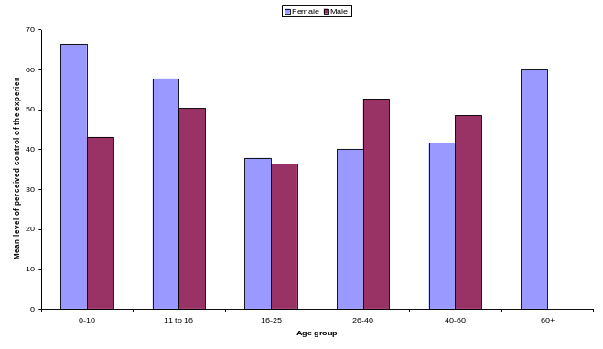
Figure 12. Response by gender to the Question "Did you feel in control of the expereince?" Mark on the line between Very much and not at all.
The other response that varied with age was enjoyment of part of the game that made you return back and forth between two known places. Children, especially younger ones, enjoyed running back and forth to places that they already knew to get the next response. Some adults found it irritating and tiring and they commented that they would prefer less “to and fro” and to visit different places in the tower grounds rather than the same ones. Ideally the game could be redesigned so that some back and forth sequences were optional, perhaps earning more reward, so that parents could elect to sit down and wait and watch while their children went back and forth and then join in again at the end of that sequence.

Follow on activities
Response to the trial was very positive and HRP were very encouraged by the potential of the game and are keen to continue exploring the technology. The use of the Active RF transmitters and receivers was very positive in terms of an interaction style. Lightweight beacons that can be carried by members of staff so that they can feature in game play without having to do more than walk around is an interesting dynamic for future game designs. The research trial was never intended to become a permanent installation system, although HRP would be interested if such a system was wholly developed. Whilst much of the trial equipment such as the RF transmitters, receivers and the charging station were research prototypes the iPAQs are real consumer products. Likewise mscape has been developed into a Beta web site where mediascapes can freely be created and published. At the moment the website supports GPS based mediascapes only because GPS is the most commonly available sensor for handheld devices.
We agreed to recreate the Prisoner game so that it just used GPS and could be made available on the mscapers web site so that anyone with a windows mobile based device with GPS could download it, visit the tower and play the game.

Redesigning the game as GPS only
To redesign the game so that it only used GPS we applied the design heuristic of “Design for coincidence”. We know from our past mediascape trials that a chance encounter between a natural event in the world and what you are hearing and experiencing in the mediascape creates a “magic moment”. For example if a black bird lands in front of you just as you are listening to a tale of black bird it makes the experience seem magical. The skill is to use your knowledge of the environment so that the chances of these natural coincidences are higher. In the Tower of London we know that Beefeaters are constantly walking around the grounds and we also know the points that they tend to stop to give talks or stand guard. In the GPS game we put regions in the areas where it is very likely that you might see a Beefeater and if you walked into that region when you were with a prisoner you would get the alert that a Beefeater has spotted you and then you have so many seconds to find the hiding place – which is another region highlighted on your device. The hope is that this may increase the feeling that the Beefeaters are some how linked in with the game because when you are caught the chances of an actual Beefeater being in sight are very high.
GPS does not work indoors and so to compensate for the lack of RF triggers inside the towers we changed the interface so that the user is asked to go inside the tower and press a button on the device when they are inside to trigger the media sequence.
The redesigned game is available for anyone to download from the mscapers web site and try out. We hope to continue to revise and improve the game based on ongoing feedback.

Further trials
Following on from the success of the trial the HRP team were keen to learn how they might develop their own mediascapes in the future. The HP team showed the HRP team how to use the mscape software in more detail and how the Prisoner game was implemented. The HRP team hope to experiment further with the software and prototype more mediascapes in some of the other Royal Palaces.

Lessons learned
In creating the Prisoner Escape from the Tower Game we created a successful design process for two distributed teams with different responsibilities. In this section we will summarize the key enablers to our success.
One of the most important success factors was to develop a shared understanding of the capability and limitations of the medium. In this case the software development platform was mscape and so specific knowledge of the interaction model and its constraints was also important. Whilst the HP team were familiar with the nuances of GPS triggered location based media, the HRP team were not. The HRP team did have a good understanding of audio tours and so were familiar with the experience of having audio delivered to you in place but the interactive possibilities of automatic media triggering and game play were new. It was important that we could co-design the experience using the same language and frame of reference drawn from a shared understanding of the medium. In an established medium such as film this shared reference is well understood as most people have seen films and film makers understand the social protocols around watching them. In this design process we could not start with the assumption that our users or everyone in the design team would be familiar with location based games and so it was essential to build up our shared understanding.
As part of building up our shared understanding it was necessary to adopt an iterative approach to design, test and redesign. This allowed us to change the design so that we did not try to take players inside the Medieval palace or other congested areas and adapt the narrative as we proceeded. Testing in situ was of course vital to understand how GPS reacts, how well the regions are placed, how players will move around the space and also to be able to tune the radio beacons. mscape supports rapid iteration as it is easy to replace media without affecting the overall design, this is an essential requirement for any location based delivery platform.
The meta design specification and schema for writing narrative scripts were also an essential part of the process. The scripts perform as important a role as that of a script for a theater play. They define the essence of the experience which can then be interpreted in many ways as a delivered experience. Just as a theater play write defines stage direction the mediascape script writer defines the way players encounter and interact with the virtual actors.
Realistic project planning, a clear division of responsibilities, deliverables and dependencies and the IT infrastructure to share documents and files across organizations were also critical elements for the design and development process.
In terms of the actual experience we found that the game structure did engage and appeal to all ages. Families welcomed the fact that their children were engaged for so long. The excitement created by the interaction with the Beefeaters in the game was a particular success. We saw how the social game mechanic of saying that Beefeaters could catch you was as effective as them technically catching you. It did not matter that not all Beefeaters were carrying transmitters their mere visual presence was enough to make players hide just in case. We will adopt the use of social mechanics in our future designs for location based games.

ACKNOWLEDGEMENTS
We would like to acknowledge the staff and helpers from the Tower of London who recorded scripts and helped to test the mediascape. We would also like to thank the extended HP labs team in particular Eleanor Jones and Paul Marsh for their help during the trial.

REFERENCES
- The murmur project http://www..murmurtoronto.ca/
- Benford, S., Seager, W., Flintham, M., Anastasi, R., Rowland, D., Humble, J., Stanton, D., Bowers, J., Tandavanitj N. and Adams, M. "The Error of Our Ways: The Experience of Self-Reported Position in a Location-Based Game,"
- Blythe, M., Reid, J., Wright P., and Geelhoed, E. "Interdisciplinary Criticism: Analysing The Experience Of Riot! A Location Sensitive Digital Narrative. " BIT, vol. 25, pp. 127-139, March-April 2006. 2006.
- Chen J. L and Liang, R. H. "The Never Ending Story: A Collaborative Narrative Storylog,"
- Facer, K., Stanton, D., Kirk, D., Joiner, R., Reid J., and Hull, R. "Savannah: mobile gaming and learning?" JCAL, vol. 20, pp. 399-409, 2004.
- Ferris, K., Bannon, L., Ciolfi, L., Gallagher, P., Hall T. and Lennon, M. "Shaping experiences in the hunt museum: a design case study," Proceedings of the 2004 Conference on Designing Interactive Systems: Processes, Practices, Methods, and Techniques, pp. 205-214, 2004.
- Halloran, J., Hornecker, E., Fitzpatrick, G., Weal, M., Millard, D., Michaelides, D., Cruickshank D., and De Roure, D. "Unfolding understandings: co-designing UbiComp In Situ, over time," Proceedings of the 6th ACM Conference on Designing Interactive Systems, pp. 109-118, 2006.
- Hull, R., Clayton B., and Melamed, T. "Rapid Authoring of Mediascapes," Proceedings of International Conference on Ubiquitous Computing Ubicomp (Nottingham), pp. 125–142, 2004.
- Kindberg T. and O'Hara, K. "You are here" - experiences with located symbols. Tech. Rep. HPL-2006-120, 2006.
- Licoppe, C. and Inada, Y. “Emergent Uses of a Multiplayer Location‐aware Mobile Game: the Interactional Consequences of Mediated Encounters” In Mobilities Vol 1, pp39-61, 2006
- O'Hara, K., Kindberg, T., Glancy, M., Baptista, L., Sukumaran, B., Kahana G. and Rowbotham, J. "Social practices in location-based collecting," in CHI '07: Proceedings of the SIGCHI Conference on Human Factors in Computing Systems, 2007, pp. 1225-1234.
- Vogiazou, Y., Raijmakers, B., Geelhoed, E., Reid J. and Eisenstadt, M. "Design for emergence: experiments with a mixed reality urban playground game," Personal and Ubiquitous Computing, vol. 11, pp. 45-58, 2007.

Columns on Last Page Should Be Made As Close As Possible to Equal Length

